ANT: MQTT and NodeRed

By Raymond Duong, ANT Computer

Engineer

Last Updated: November 14, 2021

*In this report, MQTT and the programming tool, NodeRed  
will be used together as an IOT solution  
for visualizing sensor data and   
ANT system control.  
  
  
  
  
Note: All tests will be conducted at room temperature*

*so the following results are most accurate in temperature  
range (18℃ to 25℃).*

# **Table of Contents**

**Table of Contents** **3**

**MQTT: NodeRed with Mosquitto Broker** **4**

**MQTT:Relay Board with NodeRed Dashboard Toggle** **14**

**References** **17**

# **MQTT: NodeRed with Mosquitto Broker**

**Goal:**

The goal is to use MQTT protocol in order to send sensor data to a NodeRed dashboard for easy remote visualization/reading of sensor data(Ex. a visual gauge for ph reading available on browser). Switch or toggle can also be added to the dashboard for remote control of the ANT system (ie. lights and pumps). In this test, the Raspberry PI would serve both as the MQTT broker device and the client device. The local broker installed into Raspberry PI would be open source MQTT broker, Mosquitto.

*In this report only PH readings are tested with NodeRed and MQTT

**Materials:**

Raspberry PI 3B+

Waveshare High Precision AD/DA Board

Grove PH sensor module and probe

Jumper Cables

Ethernet cable or Wifi for RPI Internet Access

**Schematic:**

**Waveshare High Precision AD/DA Board**

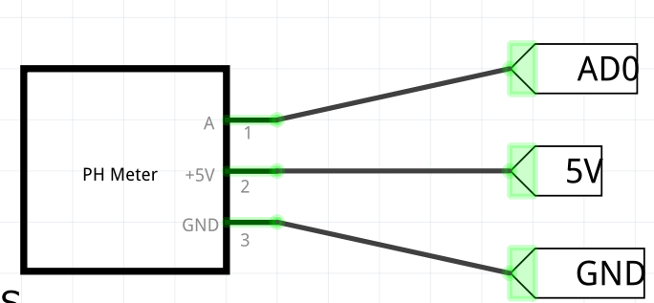

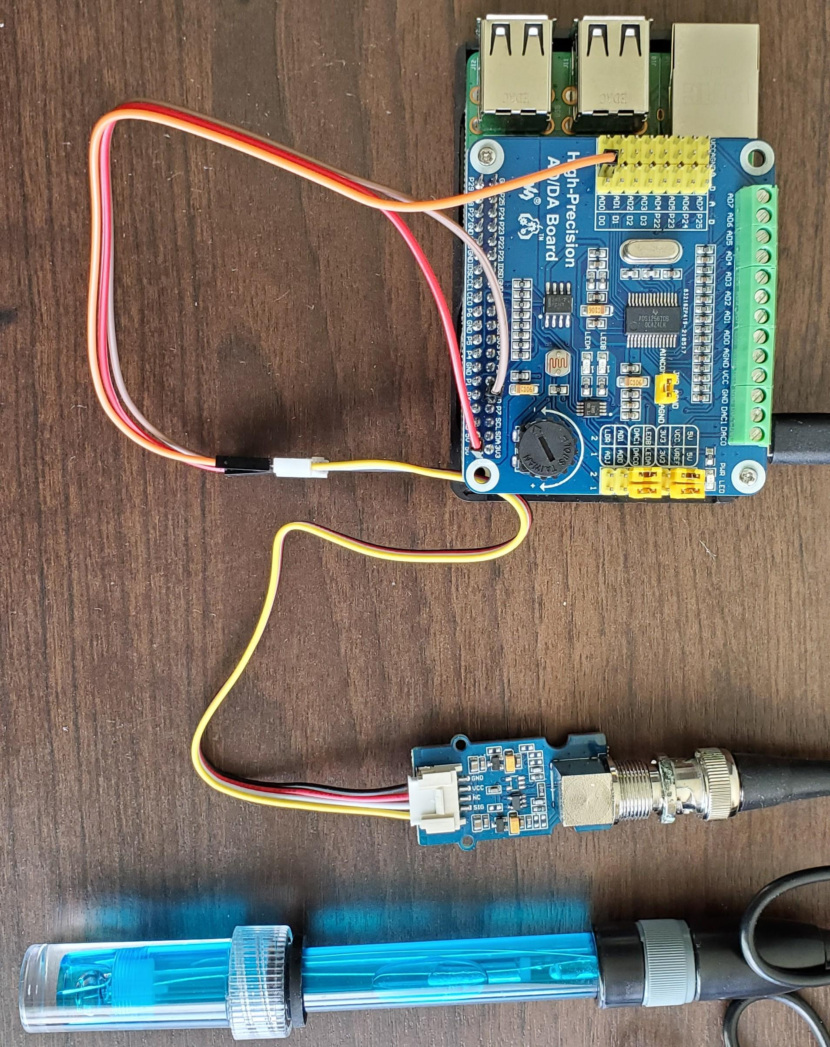

**Waveshare AD/DA Board Connection Photo (RED - 5V, BRN - GND, ORG - AD0)**

**Procedure:**

1. Connect Raspberry PI with AD/DA board and PH sensor as shown above in schematic. Setup AD/DA board with PH sensor and copy all code as shown in section “*PH Sensor: Raspberry PI and Waveshare High Precision AD/DA Board”* in *ANT:PH Sensor Report*. This report is available [here](https://docs.google.com/document/d/1y9p69sC7gd4vyk6xqqHLLcaZNMfpiaor4JzwiXDUhGo/edit?usp=sharing).
2. Install Mosquitto broker on Raspberry PI. Enter the following commands into the linux terminal:  
   **sudo apt update**  
   **sudo apt install -y mosquitto mosquitto-clients**
3. Install NodeRed and other essentials including npm and Node.js onto the Raspberry PI. Enter the following commands into the linux terminal:  
   **sudo apt update  
   sudo apt upgrade  
   sudo apt install build-essential  
   bash <(curl -sL** [**https://raw.githubusercontent.com/node-red/linux-installers/master/deb/update-nodejs-and-nodered**](https://raw.githubusercontent.com/node-red/linux-installers/master/deb/update-nodejs-and-nodered)**)**
4. Install NodeRed dashboard in by entering the following command while in directory ~/.node-red:  
   npm install node-red-dashboard
5. Another way to install NodeRed dashboard is to install it while running NodeRed and install it from the url page. Instructions available in youtube video by Defeated Engineer [here.](https://www.youtube.com/watch?v=7QOWxuuGYh4)
6. Start NodeRed by using enter the command in the terminal **node-red** or **sudo systemctl start nodered**. To run NodeRed on boot, enter the command **sudo systemctl enable nodered.service** or **node-red-pi --max-old-space-size=256.** The **node-red-pi --max-old-space-size=256** command tells Node.js to free memory faster as the Raspberry PI has limited memory available.
7. Open an internet browser to access the NodeRed IDE. Enter **http://<ip address of pi>:1880** or accessing on the PI itself [**http://localhost:1880**](http://localhost:1880)**.**
8. Create a new flow called “Dashboard PH” in NodRed IDE by clicking the ‘+’ button.
9. Create the following flow:  
   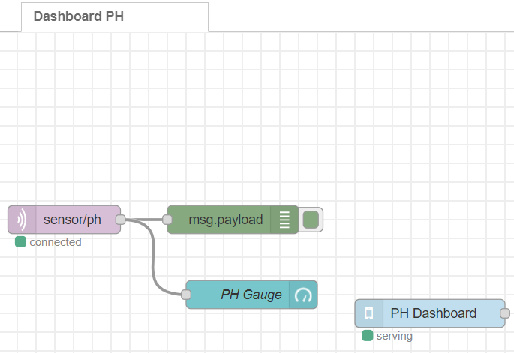
10. **MQTT Out Node Configuration:**  
    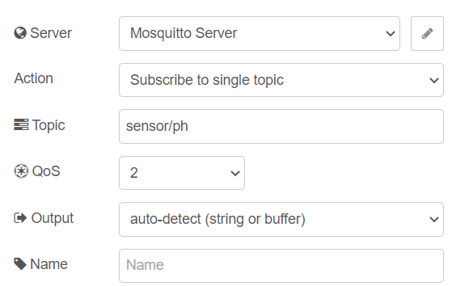  
    Edit Server properties by pressing the pencil button on the write and configure as follows.  
    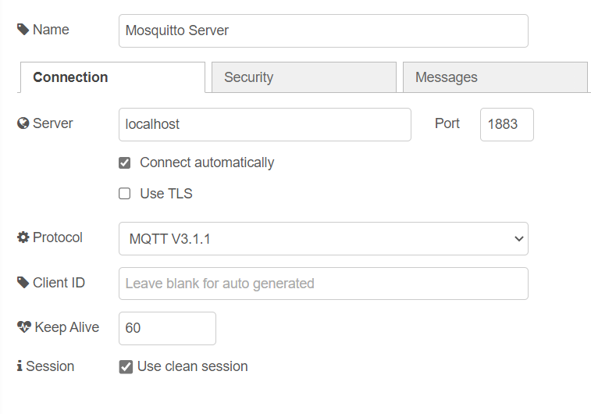  
    Enter localhost for the server address as running MQTT broker and Node-Red on the same Raspberry PI.
11. **Payload node config:**  
    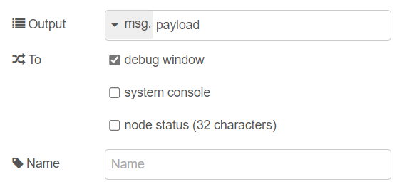
12. **Gauge node config:  
    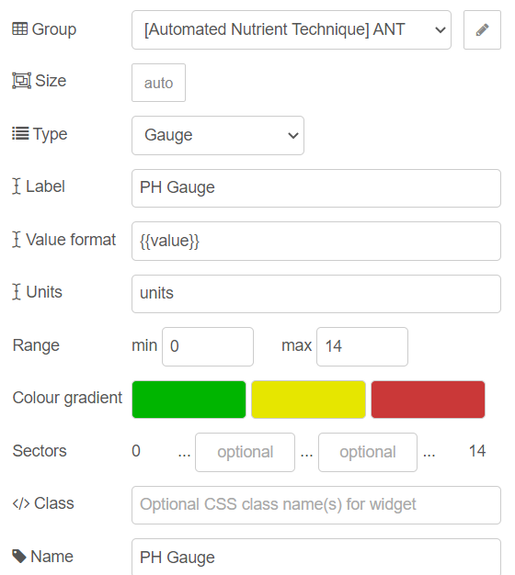  
    Group Config:  
    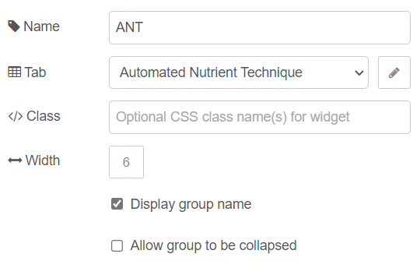**
13. Optional: To add the PH Dashboard Node or remote-access node, we need to install node-red-contrib-remote. This node is for use with the Remote-Red App.  
    *Remote-Red have a yearly subscription of $7.43 for Remote Access
14. Install node-red-contrib-remote. Open manage Palette. Search node-red-contrib-remote and press install.  
    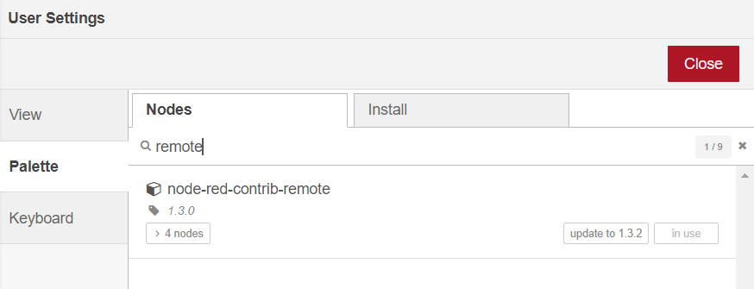
15. **Remote Access node config:  
    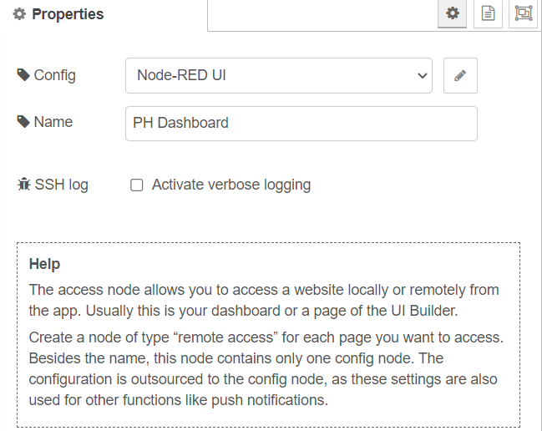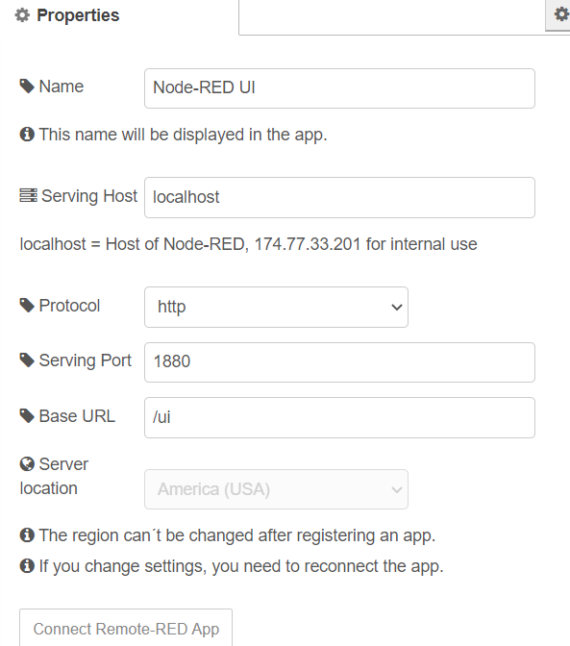**  
    Click Connect Remote-RED App button to generate QR code. Scan QR code with Remote-Red to connect to PH Dashboard on the app.
16. Deploy changes in Node-Red IDE by pressing ‘Deploy’.
17. To publish PH reading to MQTT topic, ‘sensor/ph’, we will use python library paho-mqtt to publish ph values to ‘sensor/ph’ topic. Enter “pip install paho-mqtt” in the linux terminal to install paho-mqtt.
18. Edit the main2.py file from section “*PH Sensor: Raspberry PI and Waveshare High Precision AD/DA Board”* in *ANT:PH Sensor Report*. This report is available [here](https://docs.google.com/document/d/1y9p69sC7gd4vyk6xqqHLLcaZNMfpiaor4JzwiXDUhGo/edit?usp=sharing). Edit code as follows:  
    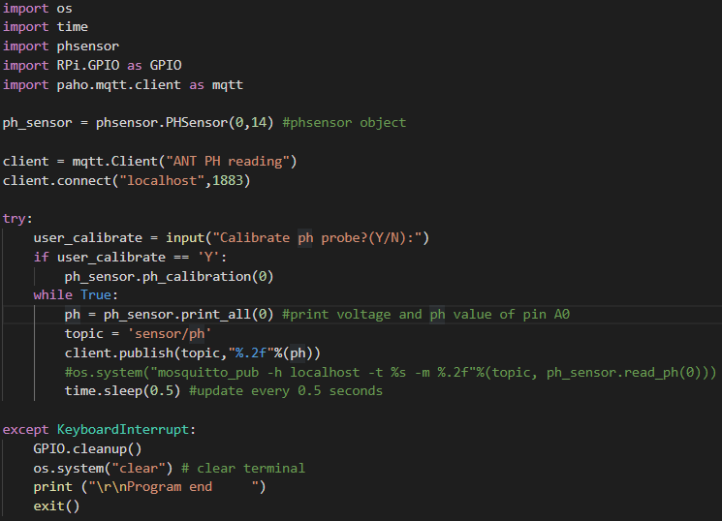
19. Start Node Red on Raspberry PI by running ‘node-red’ on the terminal if it wasn’t running already. Run ‘python main2.py’. Use Remote Red app or view the Node-Red dashboard on a browser at address ‘https://<raspberry pi ip address>:1880/ui’ to view the PH value on the gauge.

**Results:**

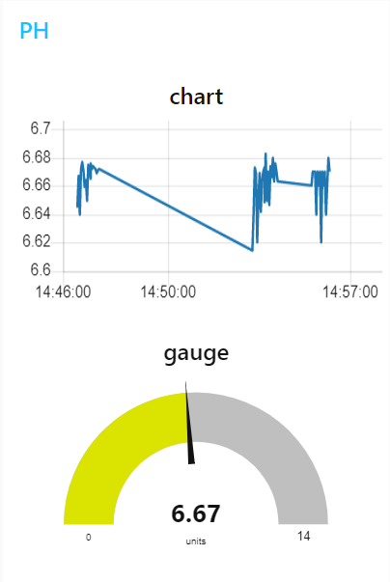  
**The chart node can also be added to graph PH readings over time**

# 

# **MQTT:Relay Board with NodeRed Dashboard Toggle**

**Goal:**

Now that we have a NodeRed dashboard setup for sensor reading, we can add more functionality to the dashboard with buttons and toggles. A button or toggle is useful for remote control of devices in our ANT system (Ex. turn on/off grow light through toggling switch in NodeRed Dashboard). In this part of the report, we will use the relay module from the “ANT:PH Sensing and Pumps report”, report available [here.](https://docs.google.com/document/d/1jC7fvxeUYAOKT8DstTtOk2fIeFTEjn26lN7woXYgpMs/edit?usp=sharing)

**Materials:**

Raspberry PI 3B+

Waveshare High Precision AD/DA Board

Grove PH sensor module and probe

Mechanical Relay Module or Solid State Relay module from “ANT:PH Sensing and Pumps report” for Raspberry PI

Jumper Cables

Ethernet cable or Wifi for RPI Internet Access

**Procedure:**

1. Follow procedure from previous section, MQTT: NodeRed with Mosquitto Broker.
2. Add a switch node and a rpi-gpio out node in the Node-Red IDE.  
   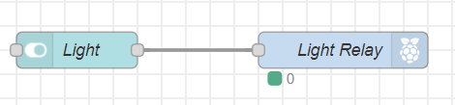  
   **Switch node config:**Use the default setting, change the ANT group as shown in the previous section, and change the name of the node to the name of the device you want to control (Ex.Light).
3. **Rpi-gpio out node config: Select the Raspberry PI pin connected to the relay control pin.  
   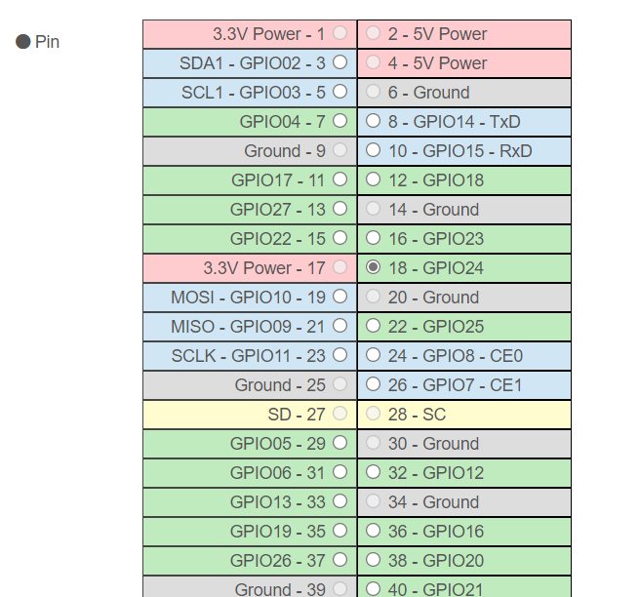**
4. Deploy changes in Node-Red IDE by pressing ‘Deploy’.
5. View Node-Red dashboard using browser or Remote-Red app. Toggle switch to control relay switch.

**Result:**

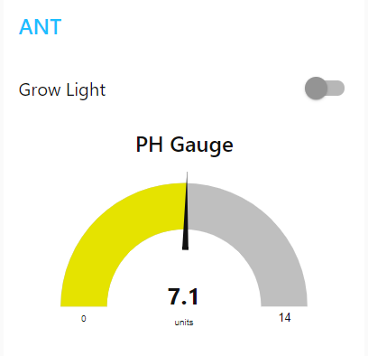

**NodeRed Dashboard with PH Gauge and Grow Light Toggle**

As expected, the device connected to the relay turns on when the switch is toggled.

# 

# **References**

* Emmet. “Installing Node-Red to a Raspberry Pi.” *Pi My Life Up*, Pi My Life Up, 7 Mar. 2020, <https://pimylifeup.com/node-red-raspberry-pi/>.
* “Running on Raspberry Pi.” *Node-Red*, Node-Red, <https://nodered.org/docs/getting-started/raspberrypi>.
* Santos, Rui, et al. “Install Mosquitto Broker Raspberry Pi.” *Random Nerd Tutorials*, 4 June 2019, <https://randomnerdtutorials.com/how-to-install-mosquitto-broker-on-raspberry-pi/>.
* Szczys, Mike. “Automate Your Life with Node-Red (plus a Dash of Mqtt).” *Hackaday*, Hackaday, 15 Jan. 2020, <https://hackaday.com/2020/01/15/automate-your-life-with-node-red-plus-a-dash-of-mqtt/>.
* The Defeated Engineer. “Node Red | Dashboard | Installation.” *YouTube*, YouTube, 2 Sept. 2017, <https://www.youtube.com/watch?v=7QOWxuuGYh4>.